INSTRUCTIONS FOR ABSTRACT SUBMISSION 2026
- Open your browser and go to www.acipet.com
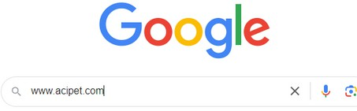

  - Click on the “Congress” button
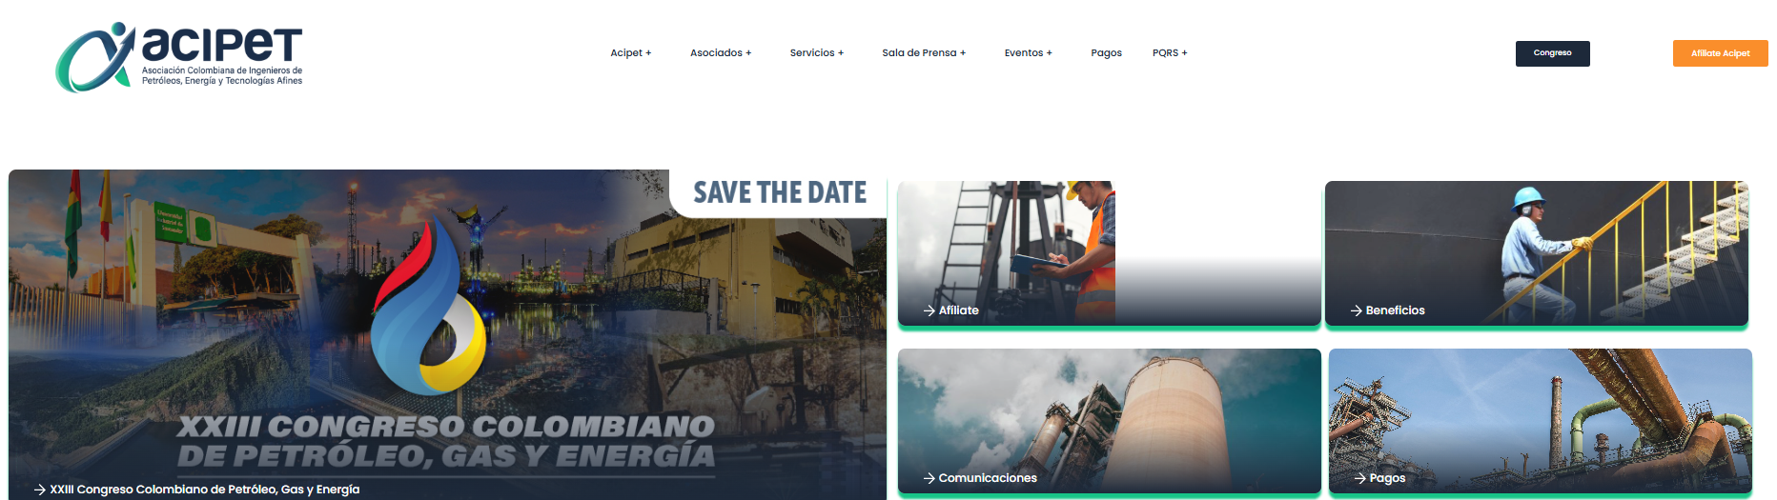
  - Enter “Technical Contest”.
  - Download the abstract template
  - Download the abstract submission instructions

- Enter the CT&F page through the button or the link:
https://ctyf.journal.ecopetrol.com.co/index.php/ctyf/login?source=%2Findex.php%2Fctyf%2Fsubmissions



- When entering the CT&F page, access with your username and password and click the Login button; if you do not have access credentials, create your user by clicking the Register button
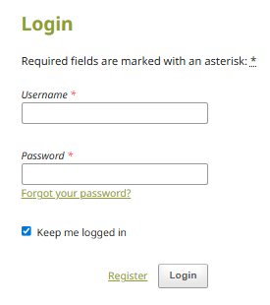
In case you click on Register, the Affiliation field refers to the company where you work. Fill in the requested information, accept the terms, and click Register.
NOTE 1: After completing the registration, you will receive an email at the address you used to register, indicating that your account has been successfully created. You must access the platform through the link that appears in that email (blue link).
NOTE 2: Enter the page with your username and password and finally click the Login button.

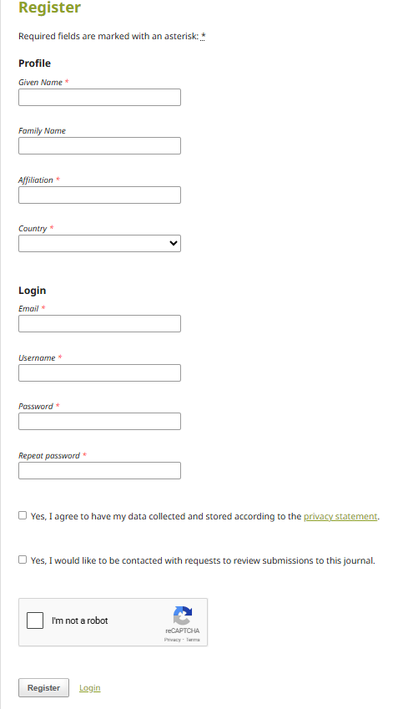
- Once inside, you will be able to see the abstracts you have previously uploaded or it will appear empty if it is your first time. To upload a new one, click on New Submission.
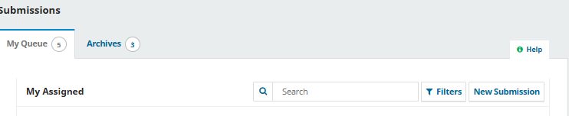
- When entering, five (5) steps to upload the abstract will appear.


  - In 1. Start, select Spanish or English, ACIPET section, check all boxes and finally click Save and continue.
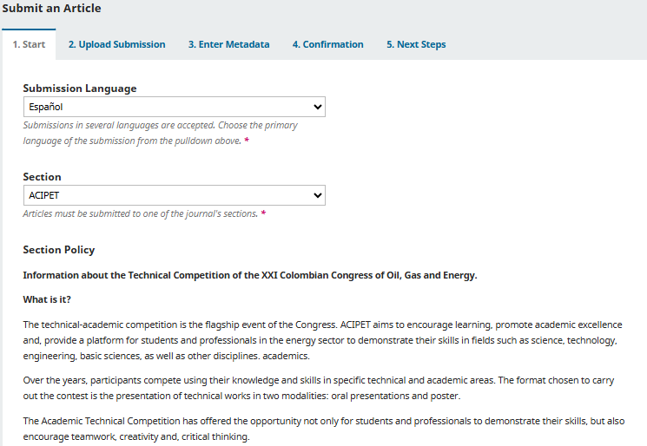

NOTE: In the comments for the author indicate the category
- Academic: (undergraduate, master's and doctoral students)
- Industrial: All industry sectors (including government)
- University–industry alliance

  - In 2. Upload Submission, upload the abstract template that you previously downloaded with the content that will be evaluated in the technical contest. Click Upload File, then select ACIPET abstract and finally click Save and continue.
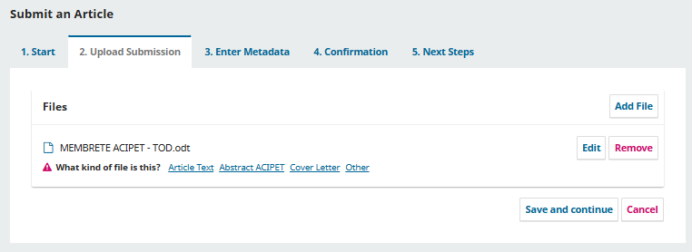
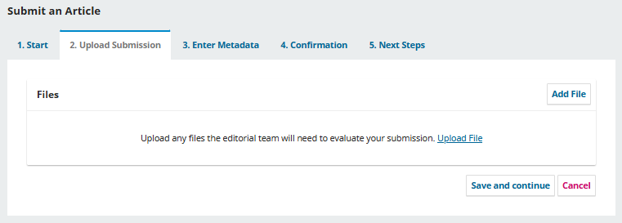
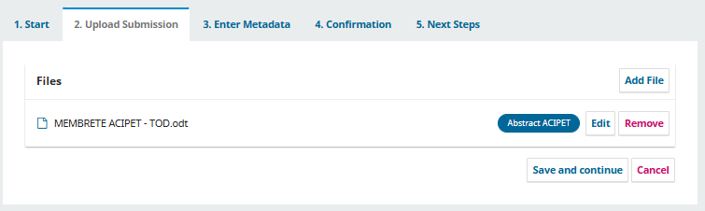

  - In 3. Enter Metadata, you will find the space to enter the information of your abstract and the details of the co-authors. In Title, enter the title you included in the abstract template. In Abstract, enter the body of your abstract. In Add Contributor, enter the information of the co-authors. After adding a co-author, they must appear in the List of contributors section (5.5 explains how to add co-authors).
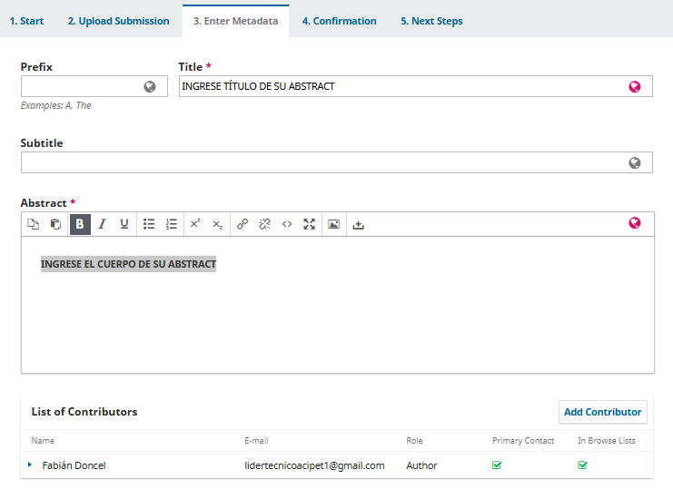
  - Finally, enter the additional information:

Coverage Information: Geographic area covered by the study
Languages: Language(s) spoken by the main author
Keywords: Keywords that identify your abstract
References: Include the bibliographic references
Funding data: If the company funding your abstract is registered, enter it in this field; otherwise, leave it blank.

Finally click Save and continue.
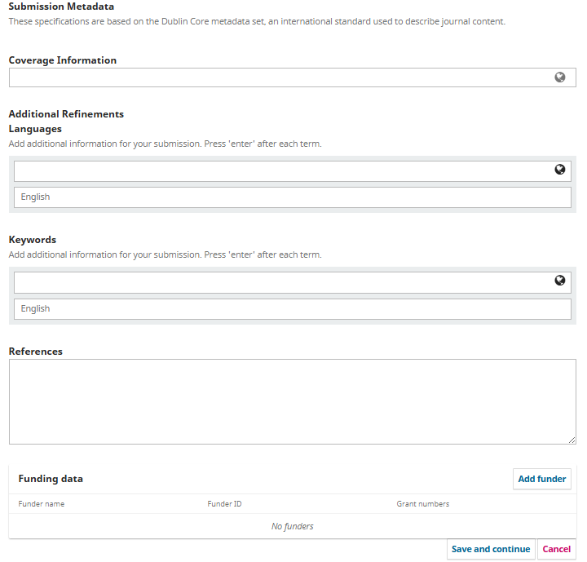

  - If you add co-authors using the Add Contributor button, a new window will appear where you must enter the co-author’s information: first name, last name, email, and country. In Contributor’s Role, select Author.

If the entered co-author will be the main contact, select the box “Principal contact for editorial correspondence.”

Select “Include this contributor in browse lists?”. With this option, the list of all co-authors will be visible in the List of contributors section. Finally, click Save.
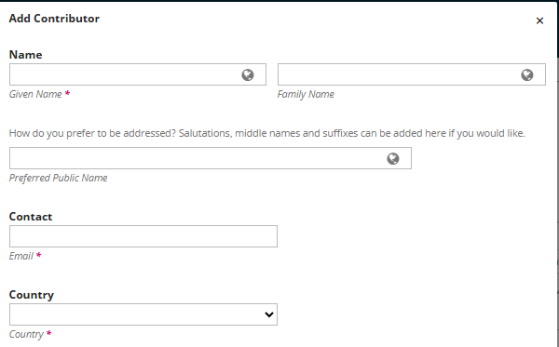
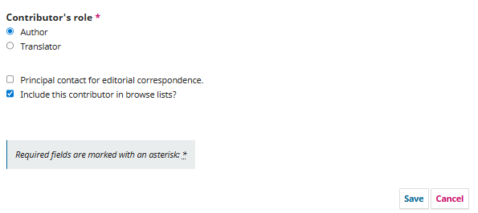

- In 4. Confirmation, confirm the submission of the abstract; please note that once submitted it cannot be modified.

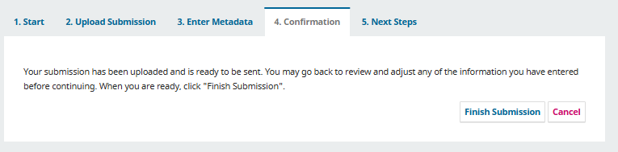
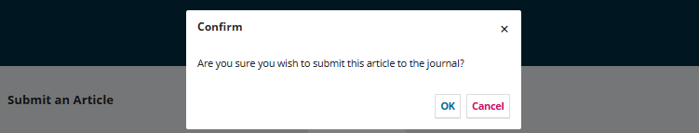

- In 5. Next steps, a message will appear indicating that your abstract was successfully uploaded to the platform.
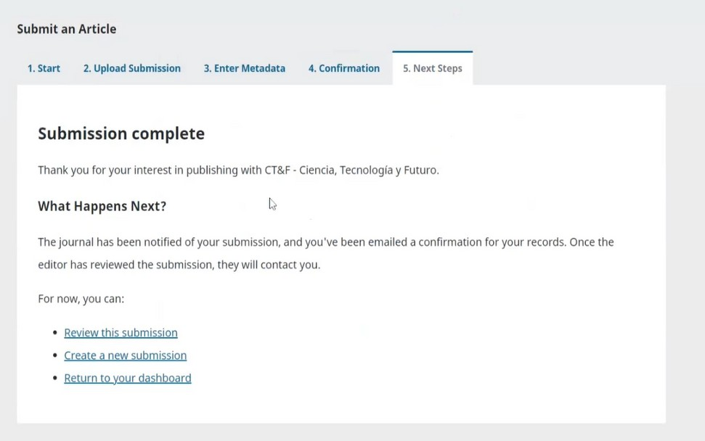
Thank you for participating in the Technical–Academic Contest of the XXIII Colombian Congress of Oil, Gas and Energy!

Remember that you have until April 28 to submit your abstract.
If you have any questions contact us at comitetecnico@acipet.com

